Repository link: https://github.com/sebass0624/ClimateProject

Topic Selection: The goal we selected was Sustainable Development Goal 13: Climate Action. This goal's main premise is to draw global attention to combat the damaging effects of climate change and to preserve our planet for future generations. This SDG is of vital importance due to the ever-increasing presence of greenhouse gas emissions, like CO2, which are warming up the planet and leading to sea level rise and extreme weather events. To accomplish this, one must collect, rigorously assess, and disseminate data to inform policy decisions and build climate awareness worldwide.

Project definition: Overall
Our team project, Global Climate Monitor (GCM), supports our chosen SDG 13 by establishing an expansive, multifaceted platform that analyzes different key climate change indicators. Our system relied on a network of three IoT-based monitors that were deployed across five global regions (the USA, Australia, India, Norway, and Antarctica). Our first readings, which were land-based, used surface monitors that were tasked with collecting data from the ground. Examples of this data include air pressure, humidity, and land-based carbon dioxide. As for our ocean readings, we utilized buoys that monitor sea temperature, oceanic emissions, and wind speed. Lastly, our high-altitude weather balloons record atmospheric CO2, ozone, and varying wind speed. By merging all these data streams, this project can provide analysts and the public with a comprehensive and nuanced view of global CO2 concentration disparities by region, allowing for a deeper understanding of the forces that drive climate change. This consolidated structure will enable us to answer critical questions, including:

1. Which country has the largest average difference in CO2 concentration according to all three monitor types?
2. What is the correlation between CO2 and land temperature amongst the different regions?
3. Based on combined CO2 data, what is the most crucial region to deploy further monitors on CO2 emissions?

Project definition: Data

The data supporting the Global Climate Monitor (GCM) is organized using a normalized relational database structure. This normalized framework ensures consistency and data integrity. The main structure is built around six tables that are separated into three one-to-many relationships. This approach achieves third normal form (3NF) and prevents errors when updating each of the tables. Foreign keys are in place to enforce these relationships, making sure that each reading is linked back properly to its original sensor. The data itself takes the form of IoT records that require meticulous definitions to maintain accuracy throughout the GCM. To uniquely identify the various emission detectors, INT types, and DATE format are used, allowing us to quickly determine which monitor we are dealing with. Additionally, climate metrics, such as CO2 and ozone, are defined with a DECIMAL type to achieve maximum precision during scientific data analysis. This efficient, integrated structure would allow us to use complex analytical queries that'll be key in helping us answer the questions surrounding our SDG 13 goal.

ER Diagram
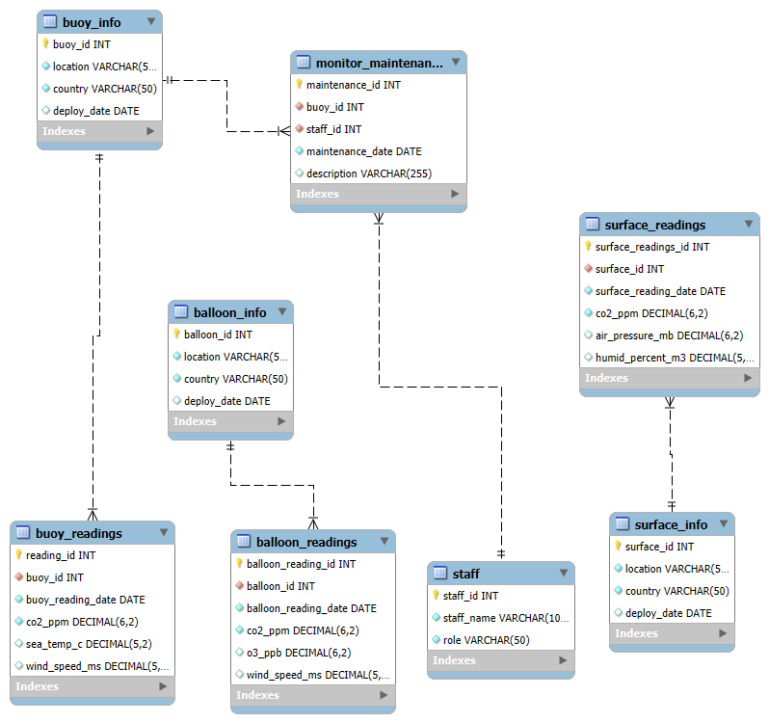
Data Dictionary (current progress):

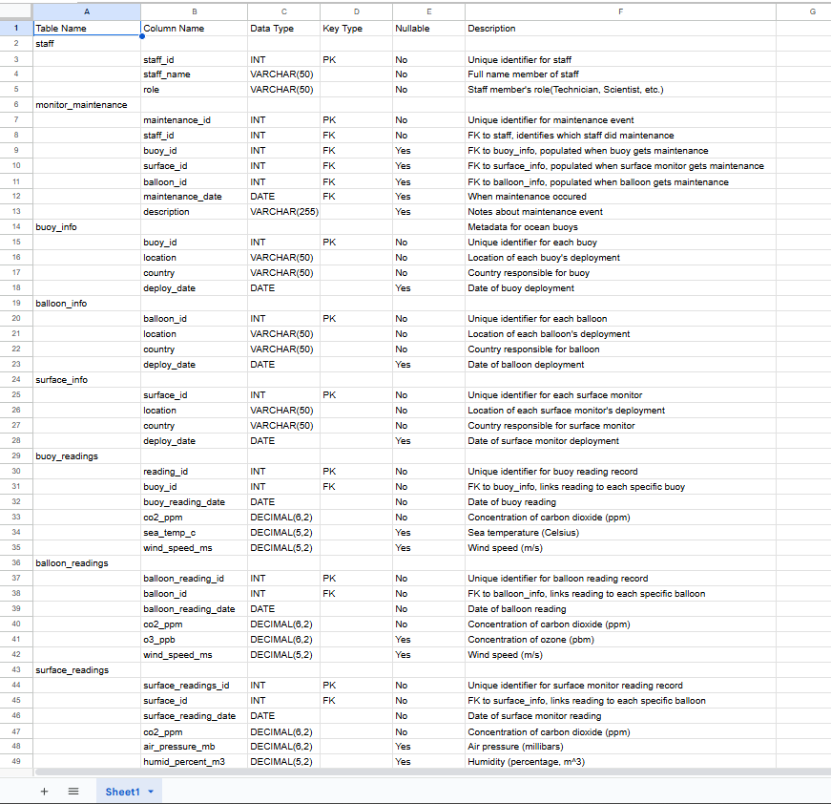

Initial Mock Testing Data/Queries (not completed)

-- DDL SCRIPT: Global Climate Monitor (GCM) Database Schema - FINAL -- This script contains the DDL, Indexes, and DML for the 8-table normalized database.

-- SECTION 1: DROP TABLES (CRITICAL: Must be in reverse dependency order)
DROP TABLE IF EXISTS buoy_readings;
DROP TABLE IF EXISTS balloon_readings;
DROP TABLE IF EXISTS surface_readings;
DROP TABLE IF EXISTS monitor_maintenance; -- M:N Junction table
DROP TABLE IF EXISTS buoy_info;
DROP TABLE IF EXISTS balloon_info;
DROP TABLE IF EXISTS surface_info;
DROP TABLE IF EXISTS staff;

-- SECTION 2: CREATE PARENT TABLES (Metadata & Staff) -- Added NOT NULL constraints for required fields like location and country.
-- 2.1 Staff Table (Parent for M:N relationship)
CREATE TABLE staff (
staff_id INT AUTO_INCREMENT PRIMARY KEY,
staff_name VARCHAR(100) NOT NULL,
role VARCHAR(50) NOT NULL
);

-- 2.2 Buoy Metadata Table (Parent for Buoy Readings and Monitor Maintenance)
CREATE TABLE buoy_info (
buoy_id INT AUTO_INCREMENT PRIMARY KEY,
location VARCHAR(50) NOT NULL,
country VARCHAR(50) NOT NULL,
deploy_date DATE
);

-- 2.3 Balloon Metadata Table
CREATE TABLE balloon_info (
balloon_id INT AUTO_INCREMENT PRIMARY KEY,
location VARCHAR(50) NOT NULL,
country VARCHAR(50) NOT NULL,
deploy_date DATE
);

-- 2.4 Surface Monitor Metadata Table
CREATE TABLE surface_info (
surface_id INT AUTO_INCREMENT PRIMARY KEY,
location VARCHAR(50) NOT NULL,
country VARCHAR(50) NOT NULL,
deploy_date DATE
);

-- SECTION 3: CREATE CHILD/JUNCTION TABLES -- Establish the Foreign Key (FK) constraints here. -- 3.1 Monitor Maintenance Table (Junction - M:N between staff and ALL monitor types)
CREATE TABLE monitor_maintenance (
maintenance_id INT AUTO_INCREMENT PRIMARY KEY,
staff_id INT NOT NULL, -- FK to staff
buoy_id INT, balloon_id INT,
surface_id INT,
maintenance_date DATE NOT NULL,
description VARCHAR(255),
-- Define Foreign Key Constraints
FOREIGN KEY (buoy_id) REFERENCES buoy_info(buoy_id),
FOREIGN KEY (balloon_id) REFERENCES balloon_info(balloon_id),
FOREIGN KEY (surface_id) REFERENCES surface_info(surface_id),
FOREIGN KEY (staff_id) REFERENCES staff(staff_id)
);

-- 3.2 Buoy Readings Table (1:N relationship with buoy_info)
CREATE TABLE buoy_readings (
reading_id INT AUTO_INCREMENT PRIMARY KEY,
buoy_id INT NOT NULL,
buoy_reading_date DATE NOT NULL,
co2_ppm DECIMAL(6,2) NOT NULL,
sea_temp_c DECIMAL(5,2),
wind_speed_ms DECIMAL(5,2),
FOREIGN KEY (buoy_id) REFERENCES buoy_info(buoy_id)
);

-- 3.3 Balloon Readings Table (1:N relationship with balloon_info)
CREATE TABLE balloon_readings (
balloon_reading_id INT AUTO_INCREMENT PRIMARY KEY,
balloon_id INT NOT NULL,
balloon_reading_date DATE NOT NULL,
co2_ppm DECIMAL(6,2) NOT NULL,
o3_ppb DECIMAL(6,2),
wind_speed_ms DECIMAL (5,2),
FOREIGN KEY (balloon_id) REFERENCES balloon_info(balloon_id)
);

-- 3.4 Surface Monitor Readings Table (1:N relationship with surface_info) CREATE TABLE surface_readings (
surface_readings_id INT AUTO_INCREMENT PRIMARY KEY,
surface_id INT NOT NULL,
surface_reading_date DATE NOT NULL,
co2_ppm DECIMAL (6,2) NOT NULL,
air_pressure_mb DECIMAL (6,2),
humid_percent_m3 DECIMAL (5,2),
FOREIGN KEY (surface_id) REFERENCES surface_info(surface_id)
);

-- SECTION 4: CREATE INDEXES
-- Indexes improve performance for lookups, especially on Foreign Keys and fields used for JOINs/WHERE clauses.
-- Foreign Key Indexes
CREATE INDEX idx_buoy_fk ON buoy_readings (buoy_id);
CREATE INDEX idx_balloon_fk ON balloon_readings (balloon_id);
CREATE INDEX idx_surface_fk ON surface_readings (surface_id);
CREATE INDEX idx_maint_buoy_fk ON monitor_maintenance (buoy_id);
CREATE INDEX idx_maint_staff_fk ON monitor_maintenance (staff_id);
CREATE INDEX idx_maint_balloon_fk ON monitor_maintenance (balloon_id); CREATE INDEX idx_maint_surface_fk ON monitor_maintenance (surface_id);
-- Analytical Indexes (e.g., for querying by country or date)
CREATE INDEX idx_buoy_country ON buoy_info (country);
CREATE INDEX idx_buoy_date ON buoy_readings (buoy_reading_date);

-- SECTION 5: INSERT MOCK/TESTING DATA (DML)
-- 5.1 Insert Staff Data
INSERT INTO staff (staff_name, role) VALUES
('Dr. Lena Jones', 'Senior Data Scientist'),
('Enrique Vasquez', 'Field Technician'),
('Sarah Chen', 'Field Technician');

-- 5.2 Insert Metadata
INSERT INTO buoy_info (location, country, deploy_date) VALUES
('Atlantic Buoy A1', 'USA', '2025-01-10'),
('Pacific Buoy B1', 'Australia', '2025-02-15'),
('Indian Buoy C1', 'India', '2025-03-06'),
('Arctic Buoy D1', 'Norway', '2025-04-17'),
('Southern Buoy A1', 'Antarctica', '2025-05-18');

INSERT INTO balloon_info (location, country, deploy_date) VALUES ('Atlantic Balloon A1', 'USA', '2025-01-12'),
('Pacific Balloon B1', 'Australia', '2025-03-14'),
('Indian Balloon C1', 'India', '2025-03-26'),
('Arctic Balloon D1', 'Norway', '2025-04-14'),
('Southern Balloon A1', 'Antarctica', '2025-05-15');

INSERT INTO surface_info(location, country, deploy_date) VALUES
('Atlantic Surface Monitor A1', 'USA', '2025-01-24'),
('Pacific Surface Monitor B1', 'Australia', '2025-02-06'),
('Indian Surface Monitor C1', 'India', '2025-04-12'),
('Arctic Surface Monitor D1', 'Norway', '2025-05-01'),
('Southern Surface Monitor A1', 'Antarctica', '2025-01-23');

-- 5.3 Insert Maintenance Data (M:N Link)
INSERT INTO monitor_maintenance (staff_id, buoy_id, balloon_id, surface_id, maintenance_date, description) VALUES
(2, 1, NULL, NULL, '2025-06-01', 'Replaced light and cleaned sensors on Buoy 1.'),
(3, 1, NULL, NULL, '2025-09-15', 'Annual calibration check on Buoy 1.'), (2, 2, NULL, NULL, '2025-07-20', 'Repaired wind speed sensor on Buoy 2.'), (2, NULL, 3, NULL, '2025-08-10', 'Replaced GPS unit on Balloon 3.'),
(3, NULL, 5, NULL, '2025-09-01', 'Retrieved and re-launched Balloon 5.'), (3, NULL, NULL, 2, '2025-08-25', 'Fixed power supply on Surface Monitor 2.'),
(2, NULL, NULL, 4, '2025-09-05', 'Replaced humidity sensor on Surface Monitor 4.');

-- 5.4 Insert Readings (Mock Data)
INSERT INTO buoy_readings (buoy_id, buoy_reading_date, co2_ppm, sea_temp_c, wind_speed_ms) VALUES
(1, '2025-10-05', 415.23, 22.5, 5.2),
(1, '2025-10-01', 414.90, 22.7, 4.9),
(1, '2025-10-04', 416.10, 22.4, 5.5),
(1, '2025-10-05', 415.75, 22.6, 5.1),
(2, '2025-10-02', 401.20, 24.3, 6.8),
(2, '2025-10-03', 400.75, 24.1, 6.6),
(2, '2025-10-04', 402.10, 24.5, 6.9),
(2, '2025-10-06', 401.85, 24.2, 7.0),
(3, '2025-10-08', 410.45, 26.4, 4.9),
(3, '2025-10-09', 409.90, 26.1, 5.0),
(3, '2025-10-06', 411.20, 26.3, 4.8),
(3, '2025-10-05', 410.95, 26.5, 5.1),
(4, '2025-10-03', 392.12, 2.1, 3.1),
(4, '2025-10-02', 391.75, 2.3, 3.0),
(4, '2025-10-03', 392.40, 2.2, 3.2),
(4, '2025-10-05', 392.00, 2.0, 3.3),
(5, '2025-10-04', 405.10, 19.4, 5.7),
(5, '2025-10-03', 404.85, 19.5, 5.5),
(5, '2025-10-07', 404.89, 19.8, 5.9),
(5, '2025-10-09', 405.45, 19.6, 5.8), (5, '2025-10-07', 405.00, 19.5, 5.6);

INSERT INTO balloon_readings (balloon_id, balloon_reading_date, co2_ppm, o3_ppb, wind_speed_ms) VALUES
(1, '2025-10-03', 415.23, 22.5, 5.2),
(1, '2025-10-09', 414.90, 22.7, 4.9),
(1, '2025-10-05', 416.10, 22.4, 5.5),
(1, '2025-10-07', 415.75, 22.6, 5.1),
(2, '2025-10-08', 401.20, 24.3, 6.8),
(2, '2025-10-02', 400.75, 24.1, 6.6),
(2, '2025-10-04', 402.10, 24.5, 6.9),
(2, '2025-10-05', 401.85, 24.2, 7.0),
(3, '2025-10-07', 410.45, 26.4, 4.9),
(3, '2025-10-08', 409.90, 26.1, 5.0),
(3, '2025-10-05', 411.20, 26.3, 4.8),
(3, '2025-10-02', 410.95, 26.5, 5.1),
(4, '2025-10-06', 392.12, 2.1, 3.1),
(4, '2025-10-08', 391.75, 2.3, 3.0),
(4, '2025-10-01', 392.40, 2.2, 3.2),
(4, '2025-10-09', 392.00, 2.0, 3.3),
(5, '2025-10-01', 405.10, 19.4, 5.7),
(5, '2025-10-02', 404.85, 19.5, 5.5),
(5, '2025-10-05', 405.45, 19.6, 5.8),
(5, '2025-10-04', 405.00, 19.5, 5.6);

INSERT INTO surface_readings (surface_id, surface_reading_date, co2_ppm, air_pressure_mb, humid_percent_m3) VALUES
(1, '2025-10-06', 415.23, 1012.50, 50.2),
(1, '2025-10-02', 414.90, 1012.70, 49.9),
(1, '2025-10-03', 416.10, 1012.40, 50.5),
(1, '2025-10-04', 415.75, 1012.60, 50.1),
(2, '2025-10-05', 401.20, 1008.30, 60.8),
(2, '2025-10-08', 400.75, 1008.10, 60.6),
(2, '2025-10-09', 402.10, 1008.50, 60.9),
(2, '2025-10-01', 401.85, 1008.20, 61.0),
(3, '2025-10-02', 410.45, 1010.40, 55.9),
(3, '2025-10-05', 409.90, 1010.10, 56.0),
(3, '2025-10-03', 411.20, 1010.30, 55.8),
(3, '2025-10-02', 410.95, 1010.50, 56.1),
(4, '2025-10-09', 392.12, 1005.10, 40.1),
(4, '2025-10-08', 391.75, 1005.30, 40.0),
(4, '2025-10-03', 392.40, 1005.20, 40.2),
(4, '2025-10-04', 392.00, 1005.00, 40.3),
(5, '2025-10-02', 405.10, 1011.40, 58.7),
(5, '2025-10-08', 404.85, 1011.50, 58.5),
(5, '2025-10-05', 405.45, 1011.60, 58.8),
(5, '2025-10-03', 405.00, 1011.50, 58.6);

